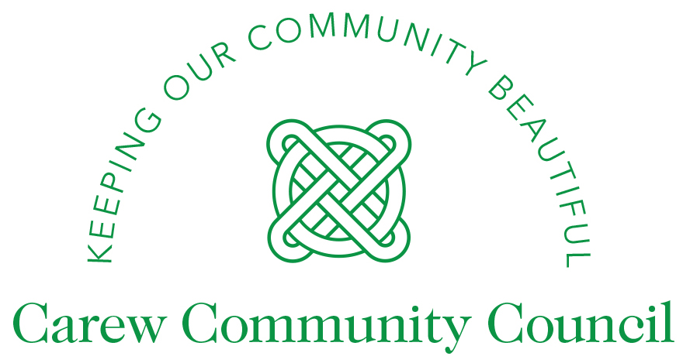
🌿 Have Your Say on the Future of Carew and Surrounding Areas
Carew Community Council invites you the residents of Carew Parish to an open and informal community meeting and we’d really love to hear from you.
📅 Date: 20th May 2026
🕢 Time: 7:30 p.m.
📍 Location: Carew Memorial Hall (next to the sports club).
Come along for a chat over tea and coffee and let us know:
✔️ What we’re doing well
✔️ What we could do better
✔️ What you’d like to see happening in our community.
We’re all committed to keeping our area beautiful, making it a great place to live, and creating opportunities to share enjoyable moments with our family and friends. Your views will help guide what we do next! From local events to improvements across the parish.
Proposed meeting Agenda:
- Apologies for Absence
- Welcome and Introduction
- Annual Report
- County Councillor Update
- Open Forum Questions, Suggestions & Ideas.

Stay and chat after, we want to hear from you all.
This is a chance to speak directly with your volunteer community councillors and help us shape what comes next for Carew and the wider community.
☕ We hope to see you there – everyone is welcome.
0-0-0-0-0-0-0-0-0

